Challenge Number 968
Played on date: October 1, 2016 Time: 2:00 pm
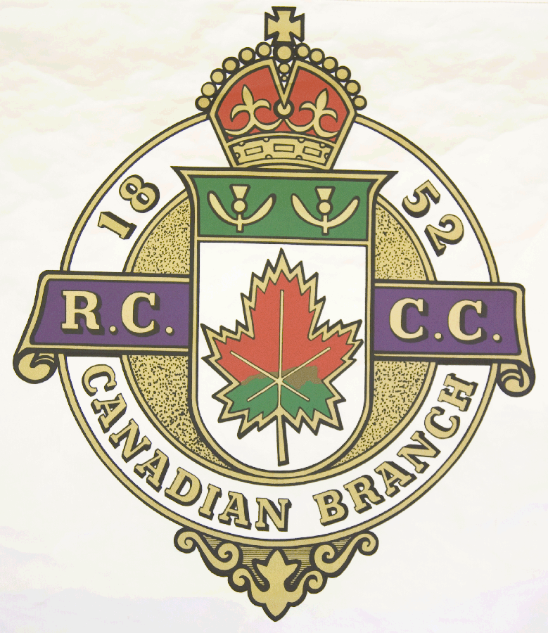
Hosting Club: Cornwall Curling Club .
Host Club Address: 20 Water St. E. .

Host Club City: Cornwall .

Host Club Telephone: (613) 936-2027 .

Host Contact Person: Neil MacLean .

Contact phone or email: cornwallcurlingboard@gmail.com

Hosting Club: Cornwall . Challenging Club: Ottawa .

Skip: Ron Leroux . Skip: Spencer Cooper ..

Third: Paul Carroll . Third: Doug Johnston .

Second: Patrick Diebel .. Second: Brian Vance .

Lead: Jace Patkai .. Lead: John Sherar .

Skip: Frank Spagnolo .. Skip: Eddie Chow .

Third: Lew Stanley .. Third: Fred Barbieri .

Second: John Rattray .. Second: Jeff Pouw .

Lead: André Parisien .. Lead: Dan Boulet .

 | Skip | 1 | 2 | 3 | 4 | 5 | 6 | 7 | 8 | 9 | 10 | Score
Sheet  3 | E. Chow | 0 | 0 | 1 | 1 | 0 | 2 | 0 | 2 | 0 | 0 | 6
Sheet  3 | F. Spagnolo | 2 | 1 | 0 | 0 | 1 | 0 | 3 | 0 | 1 | 1 | 9
Sheet  4 | S. Cooper | 2 | 0 | 2 | 1 | 2 | 1 | 1 | 0 | 2 | 0 | 11
Sheet  4 | R. Leroux | 0 | 2 | 0 | 0 | 0 | 0 | 0 | 2 | 0 | 1 | 5

Hosting club Score: 14 . Challenging club score: 17 .

Note: Description of the game should follow on separate page as well as photos of the teams.

